**Spring IOC ,Beans(Spring boot with Thymeleaf)**

Q1) Product Catalog System:

Create product class with include Product Details Attributes

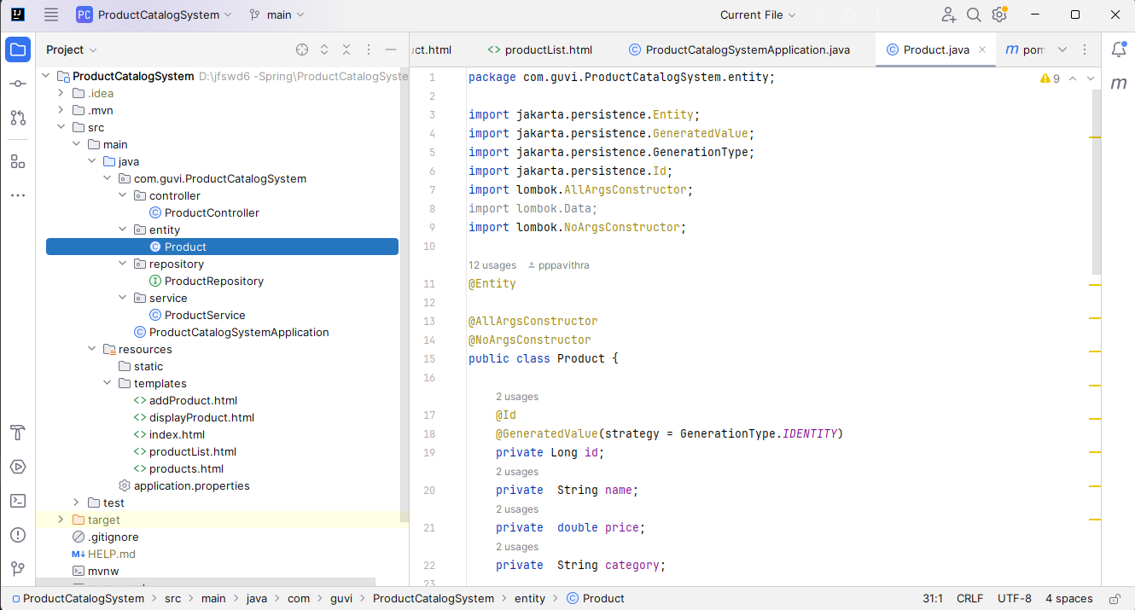

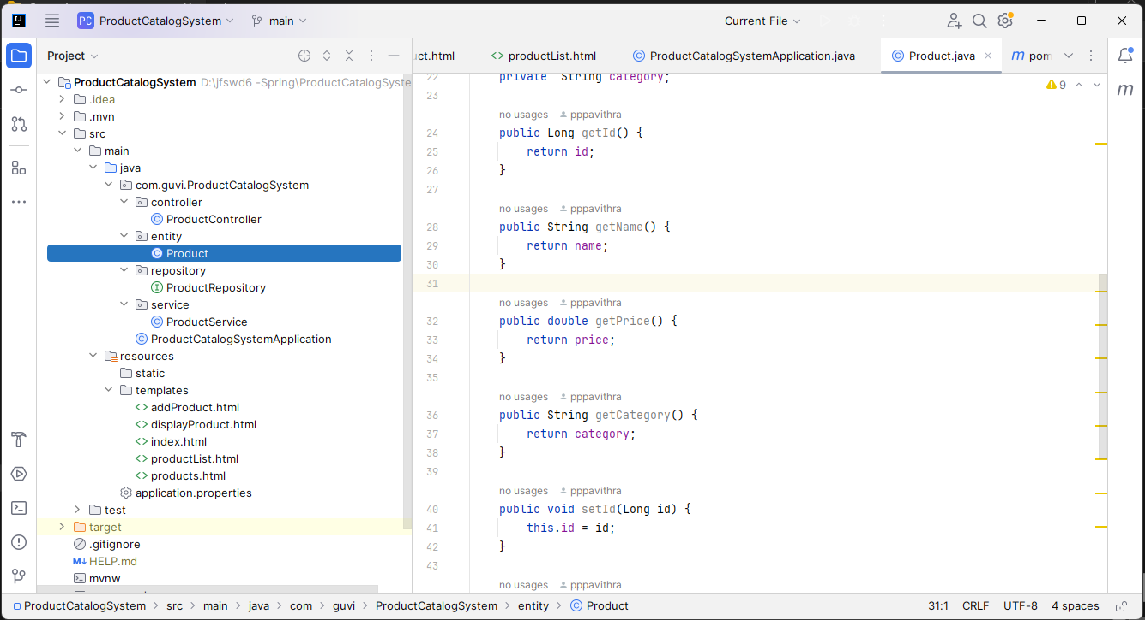

Create Product Repository Interface

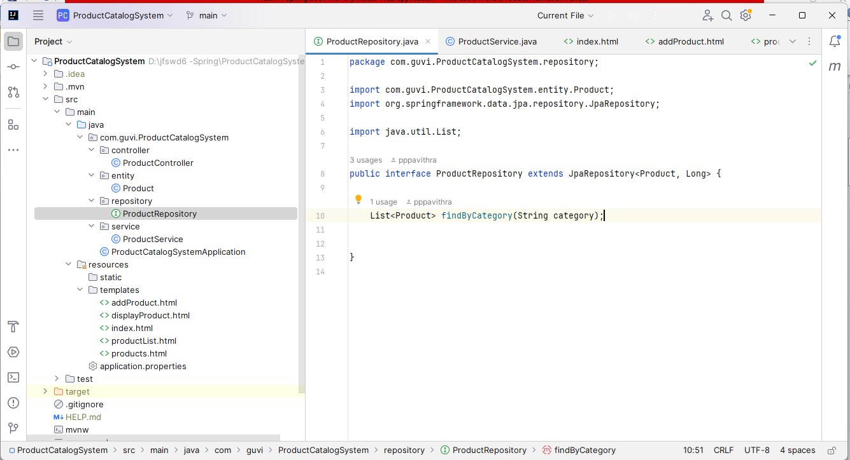

Product Service include three Method

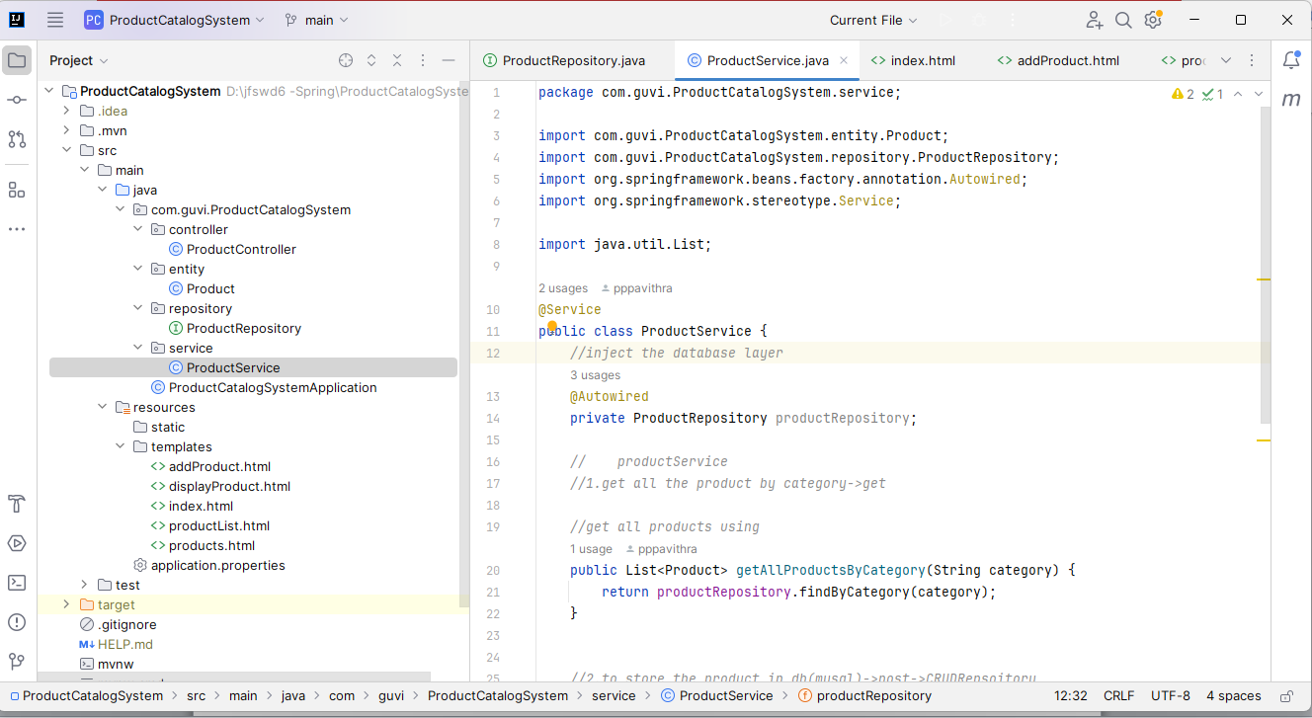

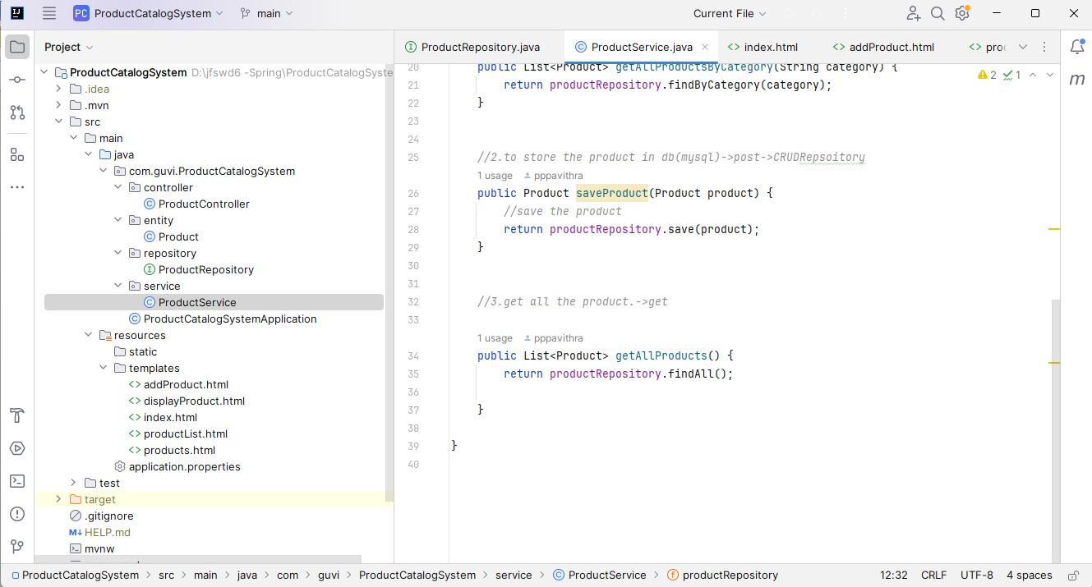

Application Properties using connectivity MySql database

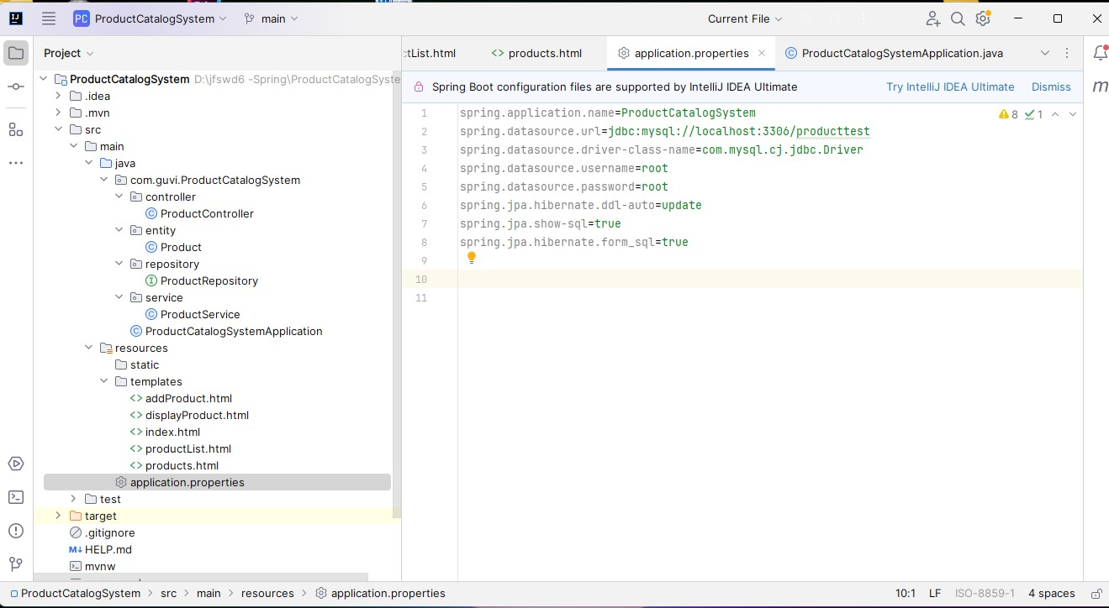

Frontend design Web develop to create index.html

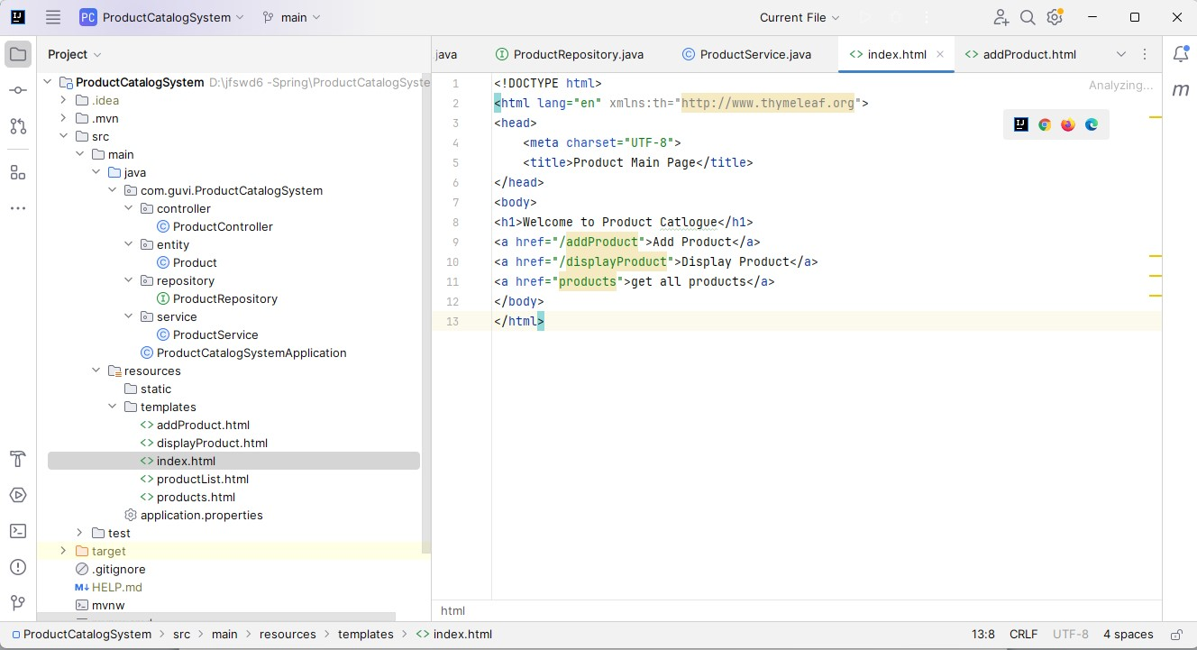

Add form into more than list of Product details

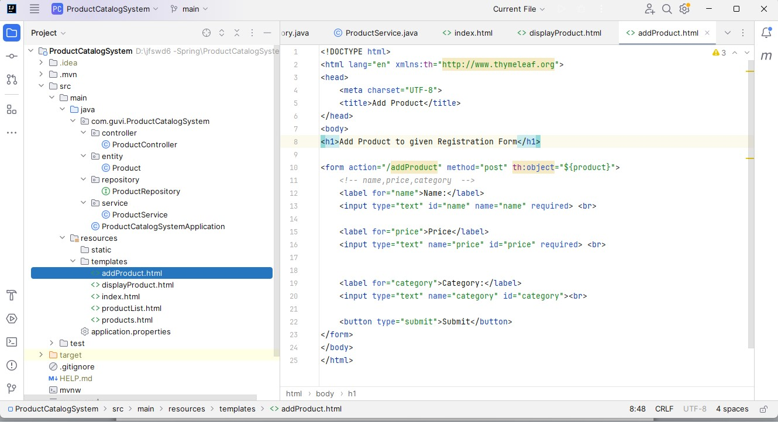

List of product details choose any one Category in display Product

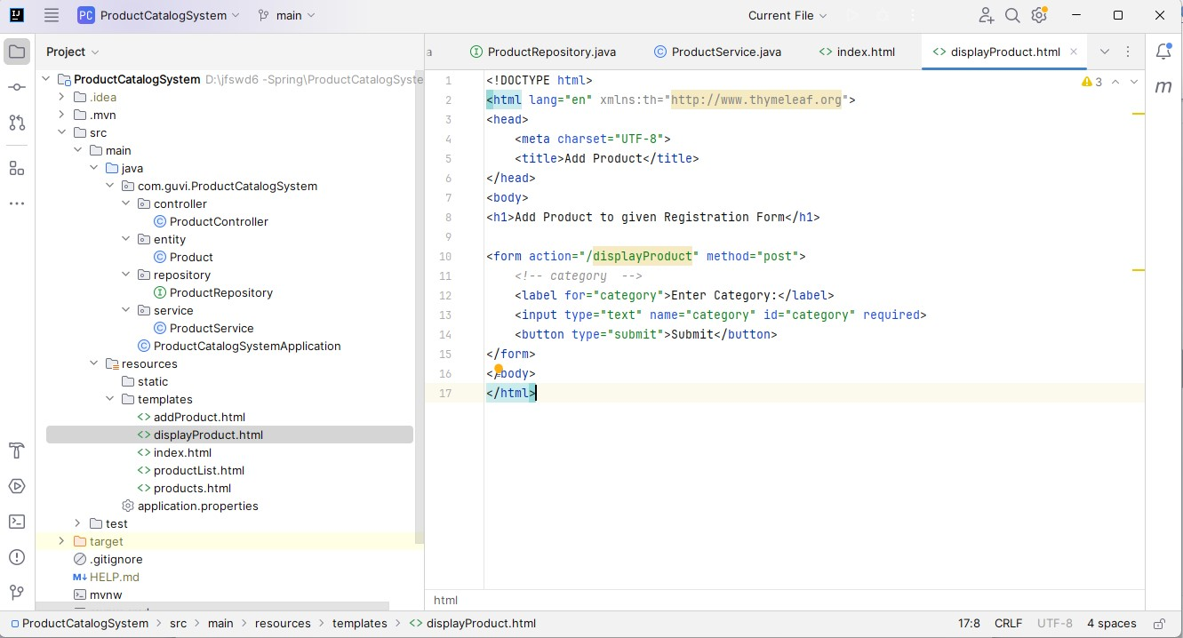

Show Product List page

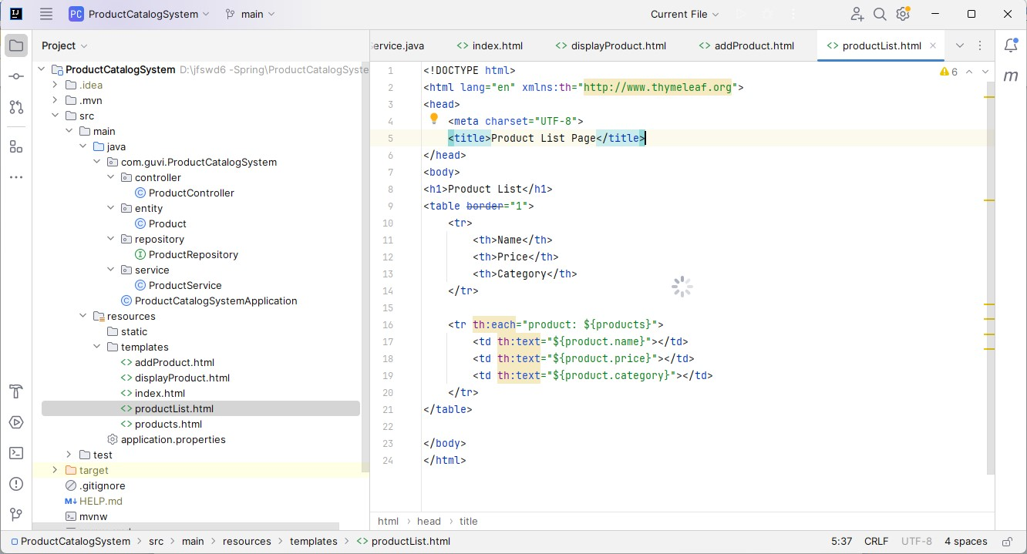

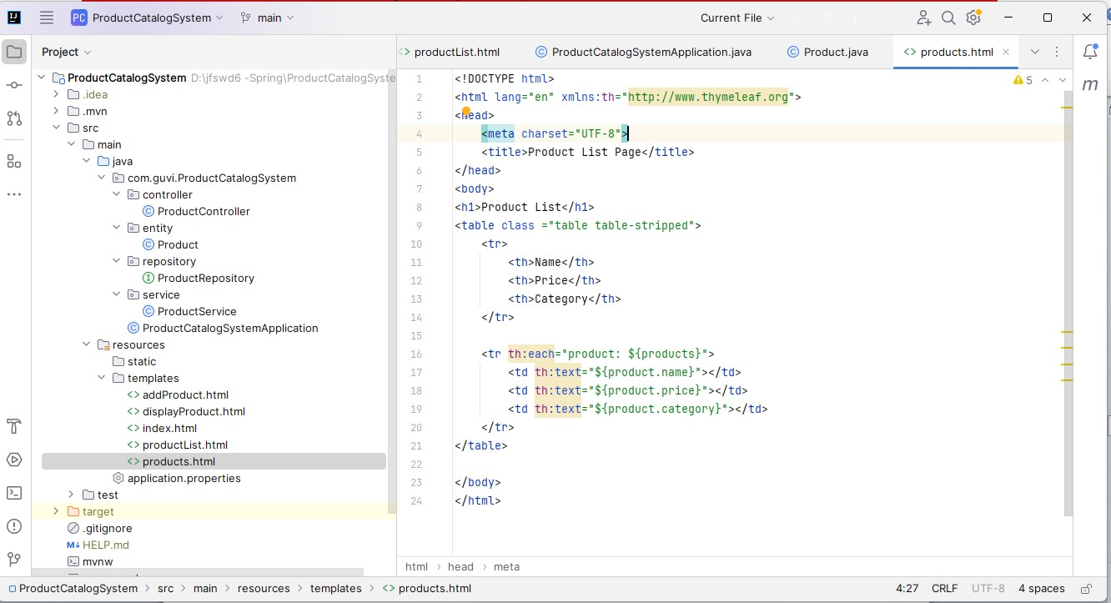

Create product controller handler all method

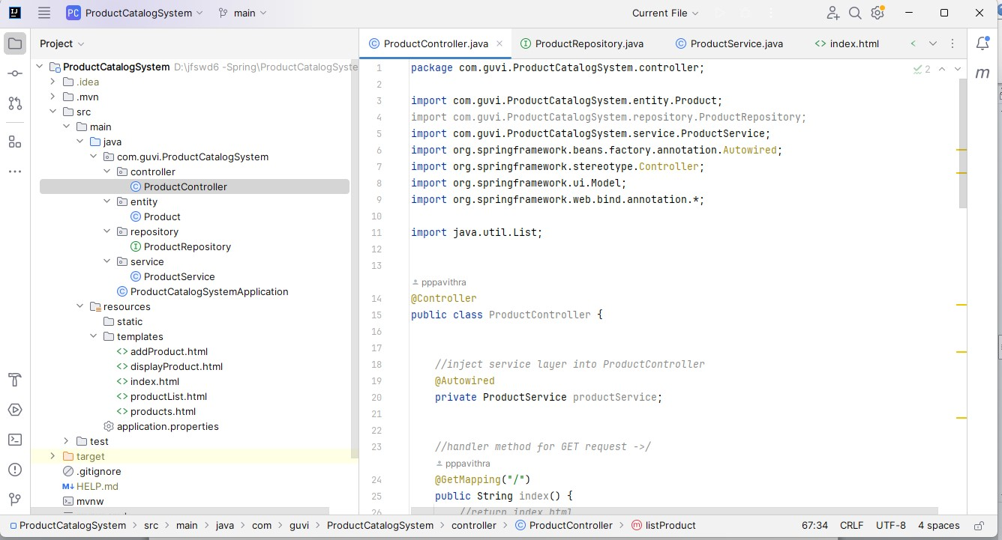

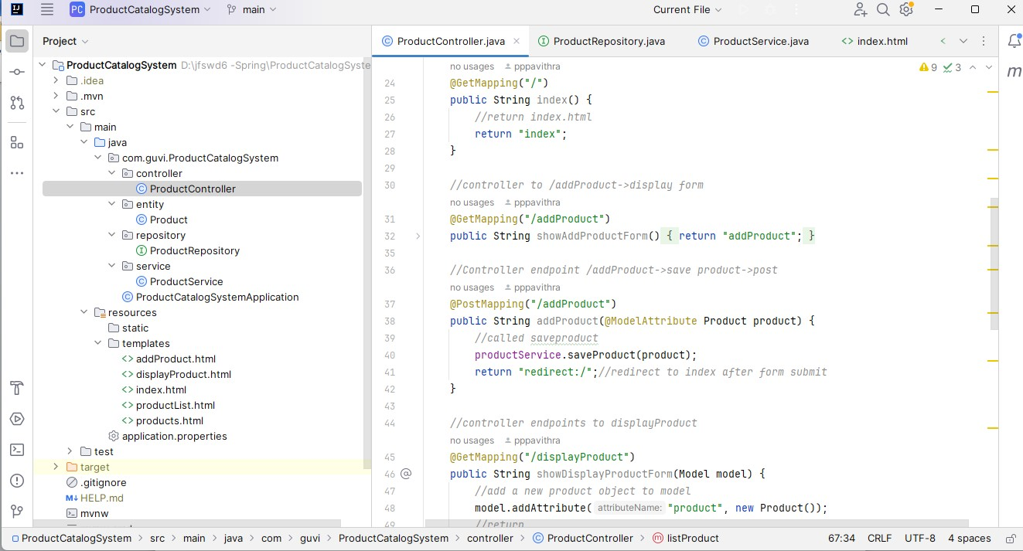

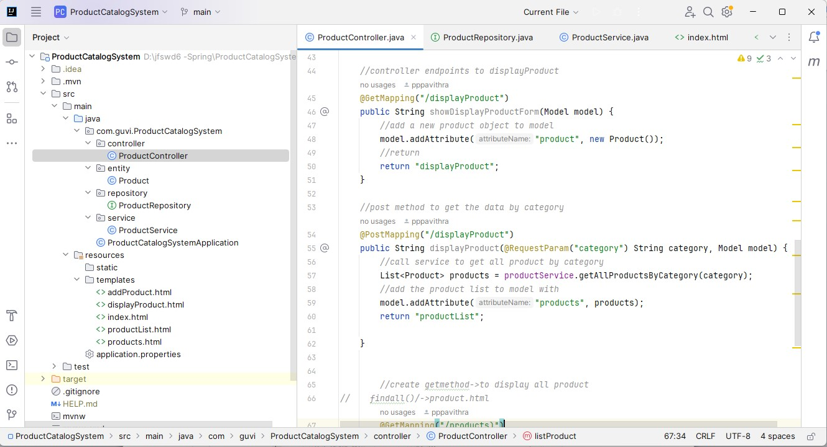

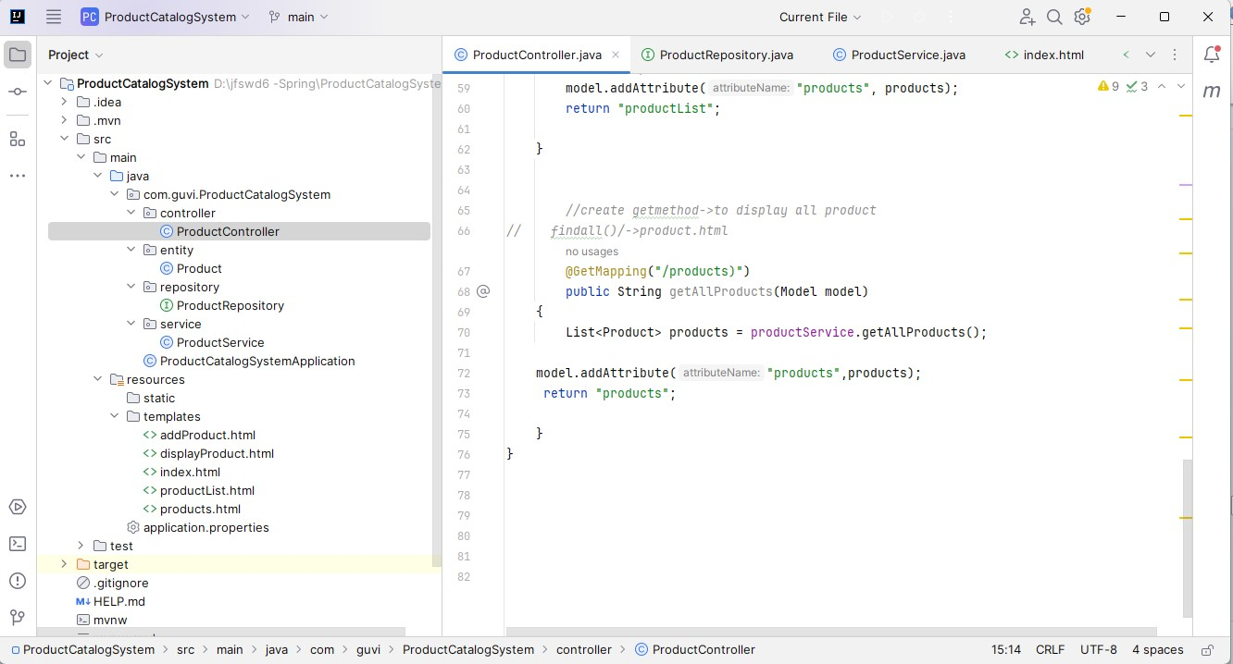

Run application

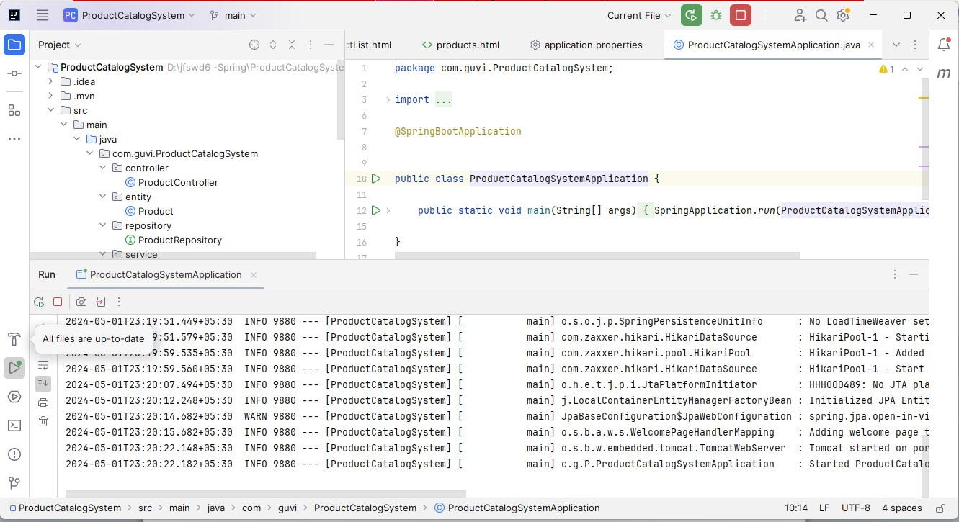

In browser localhost display welcome page to product catlogue

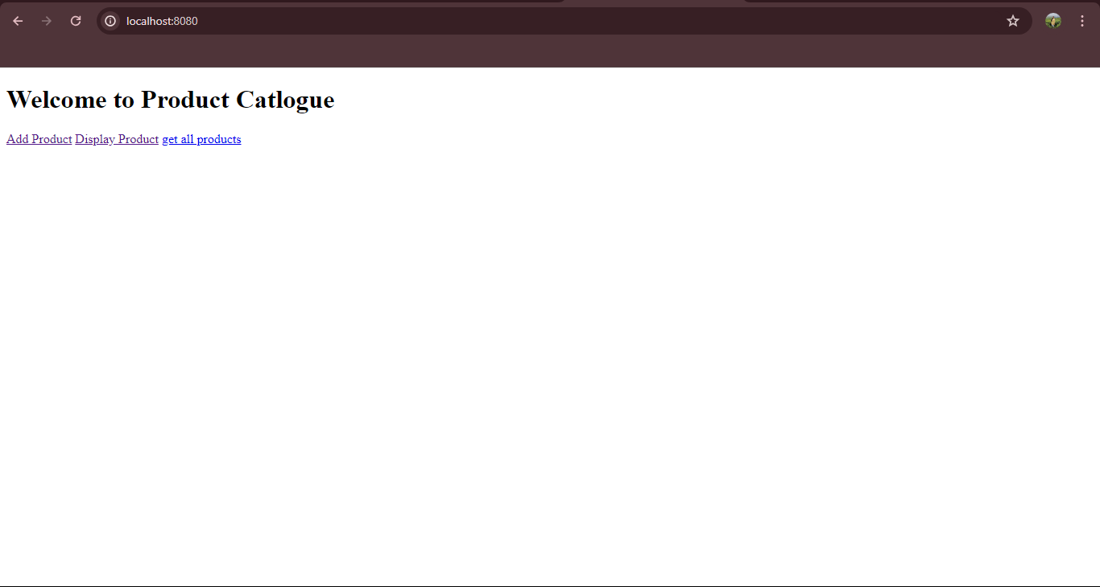

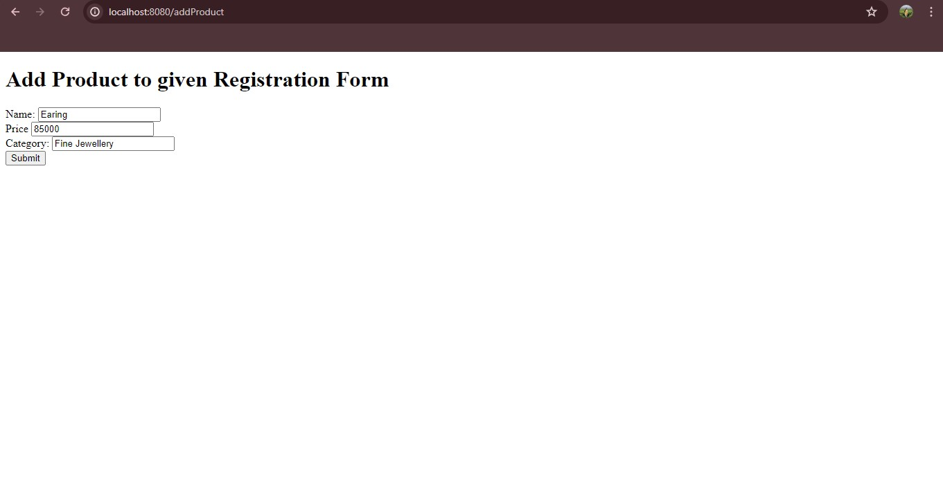

After add product details to store backend mysql database tabular format

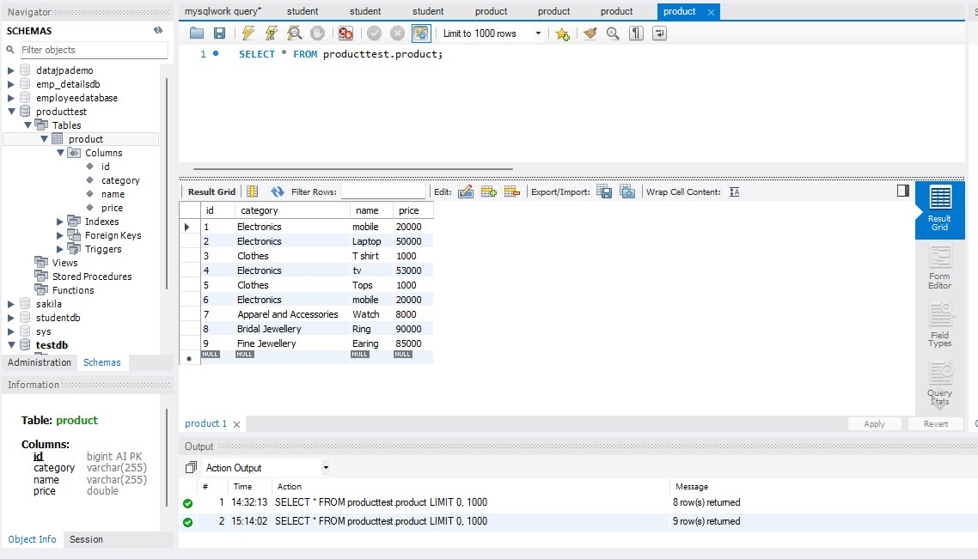

To choose database details any one product category

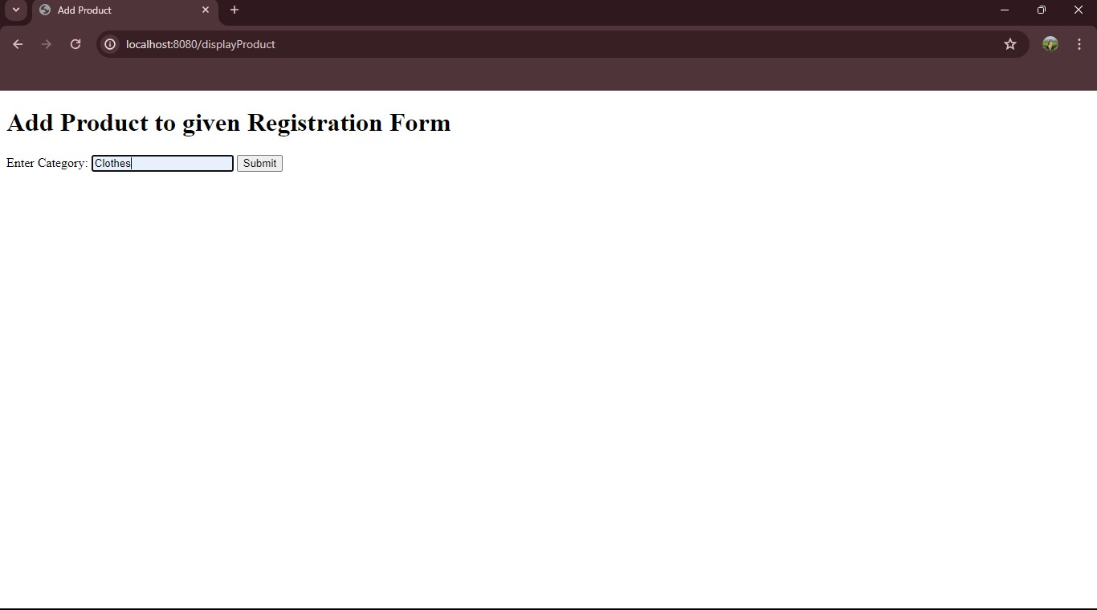

Display product list

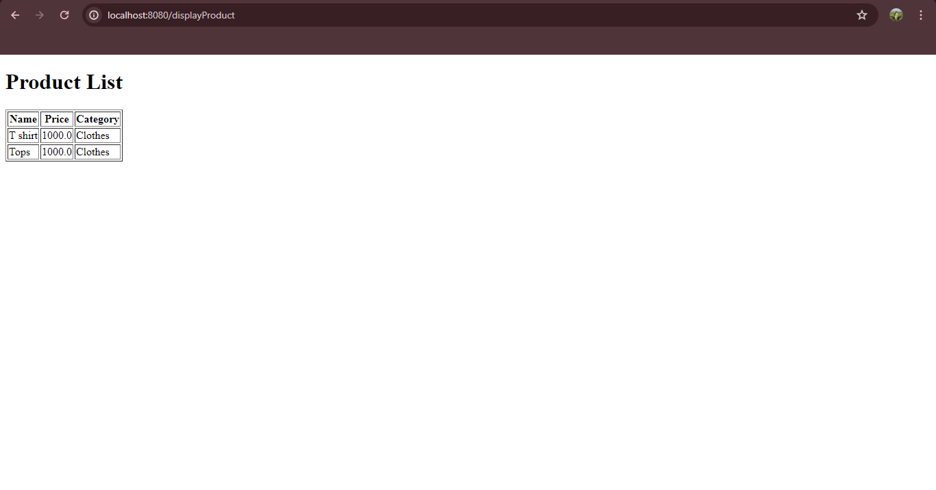

**Description:**

Create web application to implement java full stack in intellij IDE , Add dependency injection and to service,repository,controller using thymeleaf framework provide design frontend part .html resourses into connect backend process mysql database to store the data and retrieve frontend side handler controller class get,post mapping using all method.

<http://localhost:8080/>

<http://localhost:8080/addProduct>

<http://localhost:8080/displayProduct>